The Dimensions of Gredios Rulebook
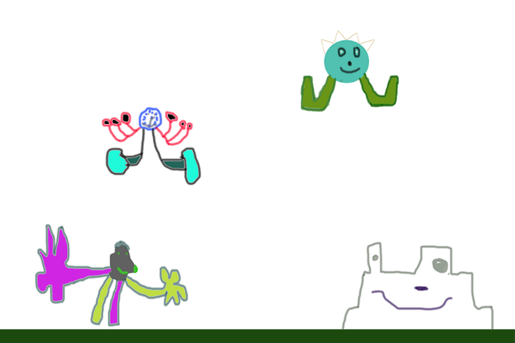

Table of Contents
Introduction……………………………………………………pg. 1
Rules……………………………………………………………...pg. 3
Life Rules……………………………………………………….pg. 4
Products…………………………………………………………pg. 5

Introduction
Welcome to The Dimensions of Gredios (TDG) trading card game. This is a fictional trading card game. The website is thedimensionsofgredios.weebly.com and the website will keep you posted about the news of TDG.
This guide will tell you how to build a deck and how to play the game. The goal of this game is to get your opponents health down to 0, or gain all 9 prize tokens.

Rules
First Turn Directions
- Draw 7 cards.
- Play 1 lvl 1 card, if you have them, as your active DT. If you do not have one you may mulligan.
- Play, if you have them, 0-5 cards to your bench.
- Put your 6 tokens beside your bench.
- If you drew any Dimensions you may put them in your Dimension Pool.
- End of turn
Next turns
- Draw 1 card.
- Play a card out of your hand, to your bench, if you need too (Dimensions, lvl 1’s, Health, and lvl 2’s.
- You may tap Dimensions so you can use a special attack or you can use the regular attack. (Your Dimensions regenerate every turn, so untap).
- Tap the cards you want to attack with.
- Tap the cards you want to block with( You can not block with a card that you have tapped to attack). (When your opponet attacks you minus the power amount of the card you blocked with).
- End of turn
- P.S. When you take a token you gain 5 power and 5 health onto ALL creatures
Life Rules
Life starts at 500. It goes down every time a character gets defeated and still has some leftover damage.
If your first hand has a DimensionWalker, you can sacrifice it and add its life - attack power to your 500 life.

Products
Pack(10 cards): $3.99
Intro Pack(Everything you need in one ready-made deck(60 cards). Includes 1 rare card, and two 10-card booster packs to expand your collection): $29.99
Prize Tokens (6): $2.99
Play mat: $3.00
Poster: $1.00
Dimension Pack(10 cards): $2.50
Health Pack(10 cards): $2.50
Deck Builders Toolkit( Contains 90 random cards, 20 Dimension Cards, 20 Health Cards): $50.00

Check out our Youtube channel at goo.gl/Q38uvX or our website at thedimensionsofgredios.weebly.com

